# STYLE HUB– AN ECOMMERCE WEBSITE FOR SHOPPING PROFESSIONAL TRAINING REPORT

**At**

SATHYABAMA INSTITUTE OF SCIENCE AND TECHNOLOGY

(DEEMED TO BE UNIVERSITY)

Submitted in partial fulfilment of the requirements for the award of Bachelor of Technology Degree in Information Technology

By

## DHARSINI M(41120054)

**DEPARTMENT OF INFORMATION TECHNOLOGY**

**SCHOOL OF COMPUTING**

**SATHYABAMA INSTITUTE OF SCIENCE AND TECHNOLOGY**

**JEPPIAAR NAGAR, RAJIV GANDHI SALAI,**

**CHENNAI – 600119, TAMILNADU**

|  |  |  |
| --- | --- | --- |
|  | **SATHYABAMA**  **INSTITUTE OF SCIENCE AND TECHNOLOGY** (DEEMED TO BE UNIVERSITY)  **Accredited with Grade “A++” by NAAC**  JEPPIAAR NAGAR, RAJIV GANDHI SALAI  CHENNAI– 600119 |  |

DEPARTMENT OF INFORMATION TECHNOLOGY

BONAFIDE CERTIFICATE

This is to certify that this Project Report is the bonafide work of **DHARSINI M (Reg.No:41120054)** who carried out the project entitled “**E-COMMERCEWEBSITE USING REACT JS**” under my supervision from June 2023 to Sep 2023.

Internal Guide

Mrs.T.G.Ruby Angel, M.Tech

Head of the Department

Dr.R.SUBHASHINI, M.E., Ph.D.

Submitted for Viva voce Examination held on

Internal Examiner External Examiner

**

**INSTITUTE OF SCIENCE AND TECHNOLOGY**

**(DEEMED TO BE UNIVERSITY)**

**Accredited with Grade “A++” by NAAC**

JEPPIAAR NAGAR, RAJIV GANDHI SALAI

CHENNAI– 600119

**DECLARATION**

I,**DHARSINI M (41120054)** hereby declare that the PT-1 Report entitled **E-COMMERCEWEBSITE USING REACTJS** done by me under the guidance of **Mrs.T.G. Ruby Angel, M.Tech** is submitted in partial fulfilment of the requirements for the award of Bachelor of Technology Degree in Information Technology.

## 

**DATE:**

**PLACE: CHENNAI SIGNATURE OF CANDIDATE**

**ACKNOWLEDGEMENT**

I am pleased to acknowledge my sincere thanks to **Board of Management** of **SATHYABAMA** for their kind encouragement in doing this project and for completing it successfully. I am grateful to them.

I convey my thanks to **Dr. T. Sasikala M.E., Ph.D.**, **Dean**, School of Computing,**Dr. R. Subhashini, M.E., Ph.D., Head of the Department** of **Information Technology** for providing me necessary support and details at the right time during the progressive reviews.

I would like to express my sincere and deep sense of gratitude to my Project Guide

**Mrs.T.G. Ruby Angel, M.Tech,** for her valuable guidance, suggestions and constant encouragement paved way for the successful completion of my project work.

I wish to express my thanks to all Teaching and Non-teaching staff members of the **Department of Information Technology** who were helpful in many ways for the completion of the project.

**CERTIFICATE OF COMPLETION**



TABLE OF CONTENTS

|  |  |  |  |  |
| --- | --- | --- | --- | --- |
| CHAPTERNO. | TITLE | | | PageNo. |
|  | ABSTRACT | | | v |
| 1 | INTRODUCTION | | | 2 |
|  | 1.1 | **PROBLEM STATEMENT** | | 4 |
|  | 1.2 | CREATING AND SETTING UP E-COMMERCE WEBSITE | | 5 |
|  | 1.3 | PROJECT STRUCTURE | | 5 |
| 2 | AIM AND SCOPE OF PROJECT | | |  |
|  | 2.1 | | AIM | 6 |
|  | 2.2 | | PROJECT OBJECTIVES | 6 |
|  | 2.3 | | SYSTEM SPECIFICATION | 8 |
|  | 2.4 | | SYSTEM ARCHITECTURE | 8 |
| 3 | EXPERIMENTAL ANALYSIS | | |  |
|  | 3.1 | EXISTING SYSTEM | | 9 |
|  | 3.2 | PROPOSED SYSTEM | | 10 |
|  | 3.3 | MODULES | | 11 |
|  | 3.4 | FOLDER | | 16 |
|  | 3.5 | MODULE DESCRIPTION | | 16 |
| 4 | RESULTS AND DISCUSSION | | |  |
|  | 4.1 | OUTPUT | | 29 |
| 5 | CONCLUSION AND REFERENCES | | |  |
|  | 5.1 | CONCLUSION | | 30 |
|  | 5.2 | REFERENCES | | 31 |

ABSTRACT

E-Commerce, also known as e-Business, or electronic business, is simply the sale and purchase of services and goods over an electronic medium, like the Internet.It also involves electronically transferring data and funds between two or more parties. Simply put, it is online shopping as we commonly know it.E-Commerce started way back in the 1960s when organizations began to use Electronic Data Interchange (EDI) to transfer documents of their business back and forth. The 1990s saw the emergence of online shopping businesses, which is quite a phenomenon today. The first-ever online purchase was a Sting CD, sold by US retailer, NetMarket on 11 August 1994.eCommerce is nothing but a type of commerce.

Its functioning style is quite similar to that of the physical retail industry. The only difference it has with a brick-and-mortar store is that here, the entire process takes place online.

The journey of an eCommerce firm begins with setting up an eCommerce website. It is usually done with plugins like WooCommerce. After that, the products are displayed along with necessary details like product descriptions and price tags.

A CTA button like “Buy Now” is placed near the products for the convenience of the customers. If they feel like buying a product they can simply click on the button and make the payment.There are different payment methods used in the eCommerce industry. Buyers either can make the payment through a payment gateway like PayPal or they can use their credit cards.

There is another option called COD or cash on delivery. This is mainly preferred by senior customers

**CHAPTER – 1**

**INTRODUCTION**

E-Commerce is a website that allows people to buy and sell physical goods, services, and digital products over the internet rather than at a brick-and-mortar location. Through an e-commerce website, a business can process orders, accept payments, manage shipping and logistics, and provide customer service.An e-commerce website is one that allows people to buy and sell physical goods, services, and digital products over the internet rather than at a brick-and-mortar location. Through an e-commerce website, a business can process orders, accept payments, manage shipping and logistics, and provide customer service.

It’s tough to imagine daily life without e-commerce. We order food, clothes, and furniture; we register for classes and other online services; we download books, music, and movies; and so much more. E-commerce has taken root and is here to stay.

The term “[e-commerce](https://mailchimp.com/marketing-glossary/e-commerce/)” simply means the sale of goods or services on the internet. In its most basic form, e-commerce involves electronically transferring funds and data between 2 or more parties. This form of business has evolved quite a bit since its beginnings in the [electronic data interchange](https://www.edibasics.com/what-is-edi/) of the 1960s and the inception of online shopping in the 1990s.

Inevitably, your customers will need to communicate with you about their order or experience. They may need to correct their personal information, make an exchange, or return a faulty product. Your website is where these customers will turn to get in touch with you. The easier you make it for customers to connect—with a contact form or chat service,Just like in a physical store, an [abandoned cart](https://mailchimp.com/marketing-glossary/abandoned-cart/) in e-commerce is one that has been filled and deserted by the shopper. While abandoned carts can be frustrating as a seller, they’re not always a bad sign. Many shoppers use their carts as a wishlist or placeholder as they look around for the right product.

The only difference is that on an e-commerce website, you don’t have to deal with a human to be able to buy and get your items delivered to your doorstep. An eCommerce website must be as functional as it is with or without the owners or managers monitoring the site and dealing with their customers every second of the day.

We are going to make a simple Ecommerce app.Regardless, you want customers to re-engage and buy those items in their cart. You can encourage them to complete their purchase by offering a discount or nudging them with a promotional email.

.

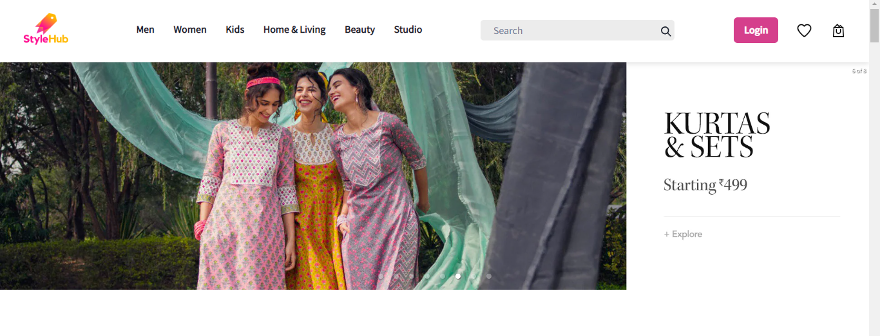

**Fig1 E-commerceWebsite**

* 1. **PROBLEM STATEMENT:**

The aim of this study is to design and implement a database driven online virtual marketplace with a particular reference to main market. E-commerce provides an easy way to sell products to a large customer base. However, there is a lot of competition among multiple e-commerce sites. When users land on an e-commerce site, they expect to find what they are looking for quickly and easily. Also, users are not sure about the brands or the actual products they want to purchase. They have a very broad idea about what they want to buy.To implement a design a better pricing mechanism in the market .

To solve the problem of geographical locationand to maximize the sales.

**1.2 CREATING AND SETTING UP E-COMMERCEWEBSITE:**

**Step 1:** Create react app using following command**.**

npx create-react-app ecommerce

**Step 2:** Now, go to the project folder i.eecom running the following command.

cd ecommerce

**Step 3**:Now install the package into your project folder using the following command.

npmstart

**1.3 PROJECT STRUCTURE:**The project structure will look like

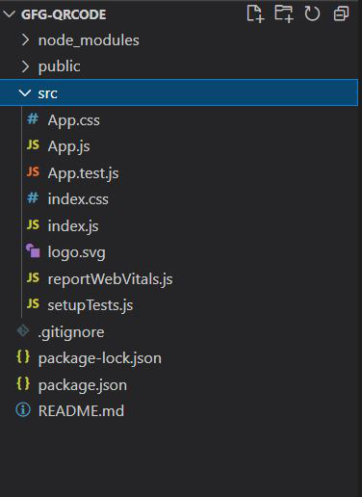

**Fig 1.3.1 Project Structure**

**CHAPTER – 2**

**AIM AND SCOPE OF PROJECT**

**2.1AIM:**

To create E-commercewebsite using React JavaScript.

**2.2 PROJECT OBJECTIVES:**

* Ecommerce businesses are the need of the moment and almost all large and small companies are taking the online route to enhance their sales and to effectively compete with similar businesses online. To turn your online business into a successful one, it is mandatory to have an in-depth understanding of how ecommerce business works, its features and characteristics and the objective of ecommerce.
* There are various features of an ecommerce business and you should be aware of all of them to set up business online. Let us understand what these features are all about.

### Technology-Enabled Ecommerce can be implemented through this website.

* Traditional commerce has been taking place since times immemorial but Ecommerce is the result of the integration of digital technology with commercial transactions and business processes. The technological foundations of E-commerce are the internet, World Wide Web (WWW) and various other protocols.
* The number of customers for a traditional business is restricted in the city where it is located, whereas an ecommerce business can reach globally. Ecommerce can be defined as a virtual marketplace that can be accessed online by customers through devices like mobile phones and computers.
* Thus, an Ecommerce marketplace motivates customers to buy products & services from any corner of the world where internet connection is available and then can pay the payment online. Due to the ubiquitous nature of the Ecommerce business, the working hours and geographical boundaries of catering enhance.
* Objective of Ecommerce for Ecommerce businesses have reached customers located all around the world. The Internet connects national boundaries. Ecommerce, without being limited by national and cultural boundaries, provides an opportunity to businessmen to cater to the customers seamlessly. This kind of marketplace has the capability to reach millions of worldwide customers.
* In Ecommerce businesses, buyers and sellers meet in cyber space rather than physical place. Hence, Ecommerce does not involve face to face contact.
* Commercial trading of products takes place through websites in Ecommerce. An Ecommerce website must be created based on the universally accepted methods and systems. Maintaining global standards aids the users of an Ecommerce website to efficiently use the website. Thus, universality of the website is one of the most essential features of an Ecommerce business.
* Interactivity serves as another important feature of an Ecommerce business. It refers to the two-way communication between the businesses and users of the Ecommerce website.
* **2.3 SYSTEM SPECIFICATION:**

**HARDWARE SPECIFICATION**

Processor : Processor Intel CORE i3 and above

RAM : 4 GB

Mouse : Digital

Keyboard : 105 Digital Keys

**SOFTWARE SPECIFICATION**

Operating System : Windows

Language : HTML, CSS, JAVASCRIPT, REACT JS.

GUI : Visual Studio (VS CODE).

**2.4 SYSTEM ARCHITECTURE:**

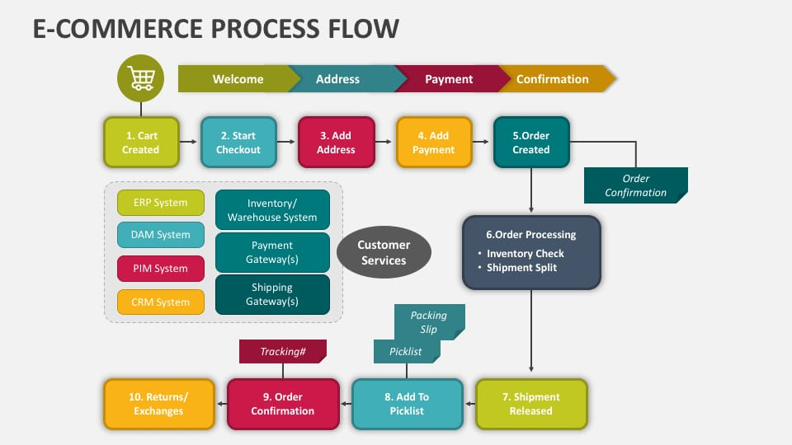

**Fig2.4.1 System Architecture**

**CHAPTER – 3**

**EXPERIMENTAL ANALYSIS**

## 3.1 EXISTING SYSTEM

* **​**Product Catalog Building is a simple solution for creating online product catalogs. Catalogs is the process of separating the products categorically and logically. The database driven system is quick to update and customize, simple to build and easy to use. Products catalog building helps to make the display of the articles or goods with product details under categories.
* E-Commerce application demands the listing of the products with detailing of the products features. The process enables the admin to add/edit/delete item or product details, product dimensions, product color (if any), product weight (if any) with option to upload images of the product and pricing.
* **Ordering System -** eCommerce system requires the products to be mentioned available (inventory) or not. If available, intended buyer have the freedom of product ordering through adding the product in the shopping cart. To be more specific, buyers can locate the product or goods by searching the key parameters or locate through product categories and then he or she can add the product to the basket or cart for further processing.
* **Multiple Currency Support -** The online application can have multiple currency support to help the product to be sold globally. I.e; a product can be listed with INR, GBP, EURO and USD to cater clients from different country.
* **Product Shipping Module -**The module helps the client to enter the product shipping details with address and the system calculates if there is any shipping charges to be levied based upon the shipping location.
* **Payment Gateway Integration** - Techno Developers Group (TechnoDG) is actively engaged in integrating payment gateway into the ecommerce application development. Payment gateway integration into e commerce websites is a good way of accepting payment for products or services offered by online shopping.
* **Product Review -** A review is an evaluation of a product with marking which helps other buyers to decide on the purchase. Our online application is empowered with product review to help consolidate user opinions about a particular product.
* Even we share the URLs through barcode or E-commerce but we can’t store lengthy URL in a small E-commerce so the link will be shortened and later it will be stored in the E-commerce for sharing of the link.

## PROPOSED SYSTEM

* A review is an evaluation of a product with marking which helps other buyers to decide on the purchase. Our online application is empowered with product review to help consolidate user opinions about a particular product.
* Our online application enables the users to register themselves with the ecommerce portal. This way the application can store purchase history, can track purchase trends, can send time bound newsletters (if opt separately) specifying new deals, offers, promotional materials etc. Other then the customer database can be used for making survey to decide on product inventory, product promotion etc.
* E-Commerce application system has a major part called Product Order Management which helps the admin to track product ordered and automate the product dispatch, create invoice, decide on shipments and confirm the product after dispatch to be tracked by the client with unique id
* Our eCommerce website development team will do their best to advise you on the perfect designing of your site so that it works best for your business

## There are many numbers of ways in creating short URL. The URLs are created by using the base36 which consists of 26 letters and 10 numbers. That is the short URL will be presented as 0 to 9, a to z and it also consists of capital letters and as well as lowercase letter the it will be within base62.

## To create the key some numbers website must be created so that the sequence of key will be unique and it won’t be able to predict or else users will have their own keys to create their short URL. All the protocols are not possible to shorten, some protocols like ftp, http, ftps etc., are being address as URL shortener.

**3.3MODULES**

**NAMES OF THE MODULES:**

1. Algorithm
2. URL Shortener Base62 Algorithm

First of all, you have to create a folder in desktop or any disk. After that you have to open folder in VISUAL STUDIO CODE. After that open new terminal in Visual Studio Code.

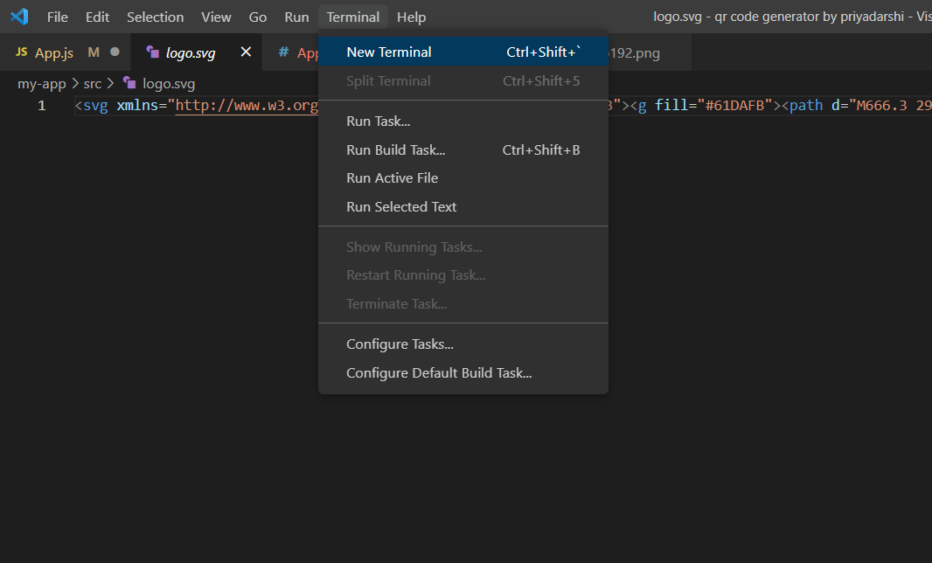

**Fig 3.3.1 Open NEW Terminal**

## QUICK START

npx create-react-app my-app

cd my-app

npm start

## CREATING AN APP

**npx**

npx create-react-app my-app

### **npm**

### npminit react-app my-app

### **yarn**

yarn create react-app my-app

**HOW TO USE**

1.You will need Git and Node.js installed on your computer.

To establish this: I have use Node.js and many otherapplications.

-- to install node/install dependencies: npm install (in console/terminal)

--to install script: npm install react-scripts

--npm audit fix

--force (to fix bugs).

--npm install node-fetch

--npm start -> Runs the app in the development mode.

Open LocalHost:**http://localhost:3000** to view it in the browser.

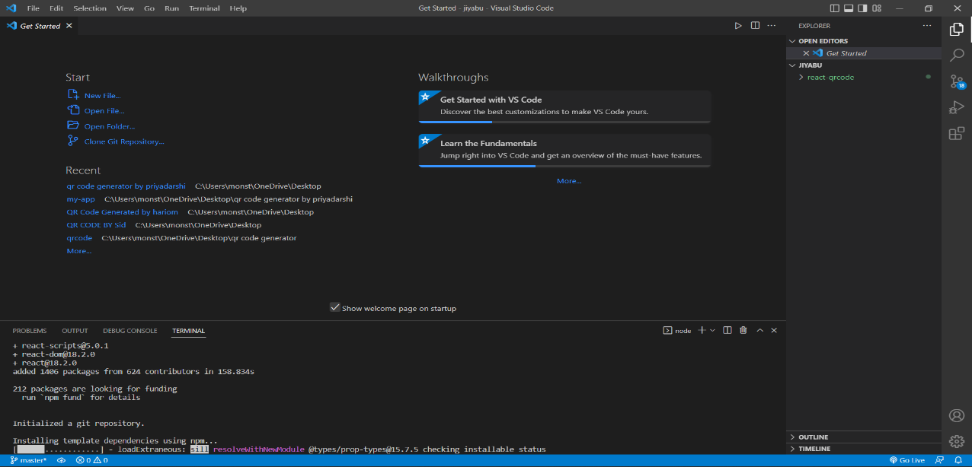

**Fig 3.3.2 Installing Modules**

# C:\Users\HP\Desktop\Screenshots\Screenshot (1313).png

# Fig 3.3.3 Starting the App

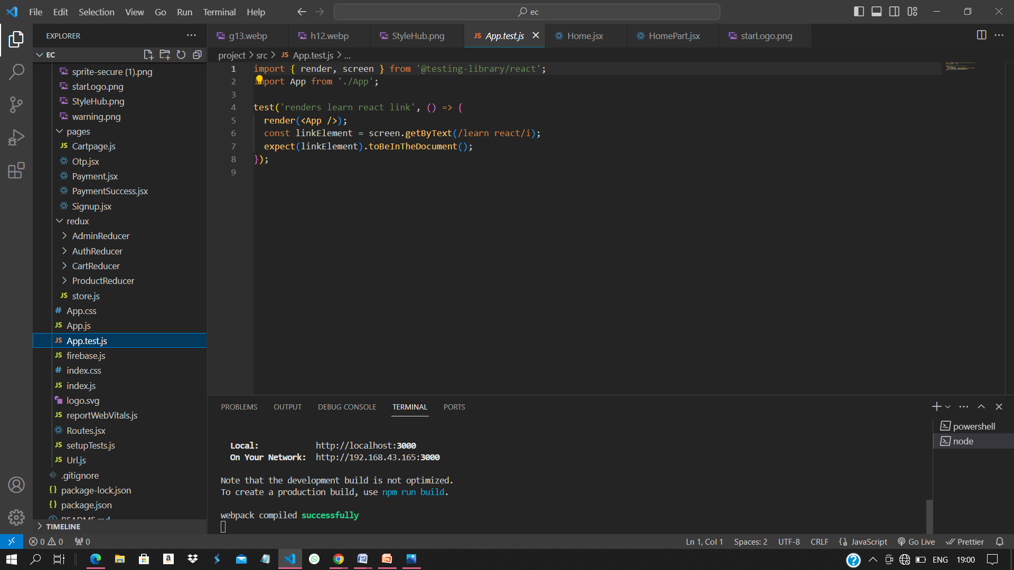

**Fig 3.3.4 Complied Successfully**

NOTE:

* That the development build is not optimized.
* To create a production build, use npm run build.
* The page will reload if you make edits.
* Might see any lint errors in the console.

**npm test:**

Launches the test runner int interactive watch move

**npm run build:**

Builds the app for production to the build folder.

Itcorrectly bundles React in production mode and optimizes the build for the best performance.

The build is minified and the filenames include the hashes.

Package install: npmi react-qr-code

**GETTING STARTED WITH REACT:**

npx create-react-app myqrcode

cdmyqrcode

npm start

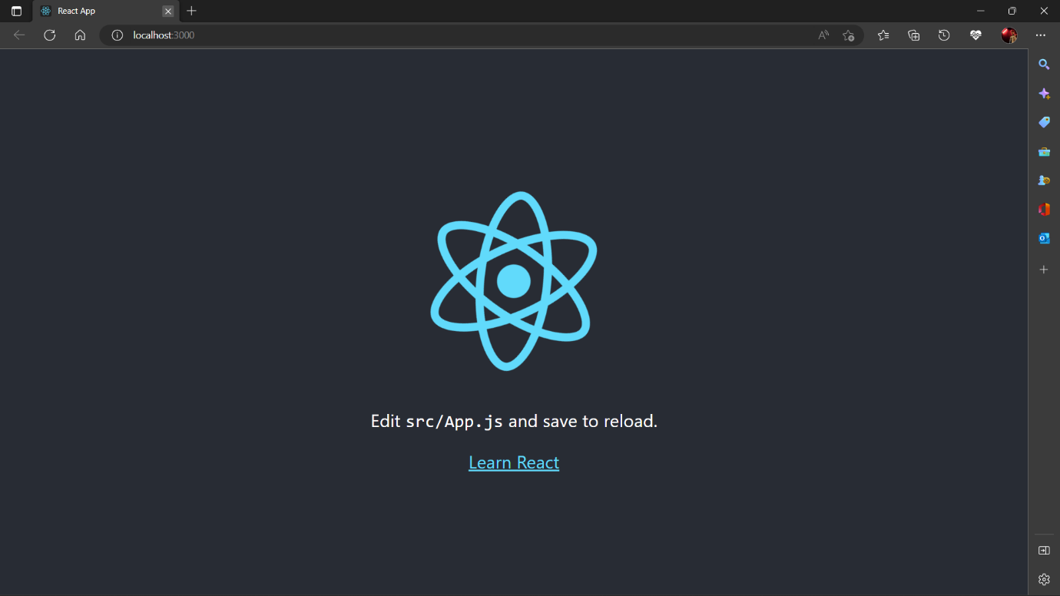

**Fig 3.3.5 React App**

**3.4 FOLDER**

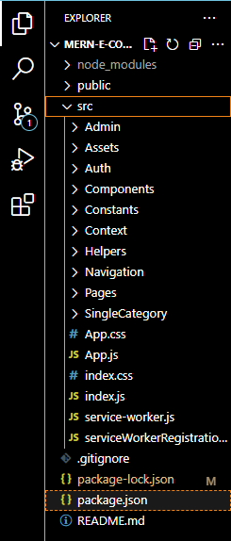

**Fig 3.4.1 Visual Code Side Bar**

3.5MODULE DESCRIPTION

***3.5.1ECOMMERCE WEBSITE Algorithm.***

**(App.js)**

import "./App.css";

import AllRoutes from "./Routes";

import CartEmpty from "./component/Rahul/Cart/CartEmpty";

import CartPage from "./component/Rahul/Cart/CartPage";

import Navbar2 from "./component/Rahul/Navbar2";

import PaymentPage from "./component/Rahul/PaymentPage/PaymentPage";

function App() {

return (

<div className="App">

<AllRoutes />

{/* <Navbar2 /> */}

{/* <CartEmpty /> */}

{/* <CartPage /> */}

{/* <PaymentPage /> */}

</div>

);

}

export default App;

***3.5.2 E-COMMERCE WEBSITE Algorithm.***

**(index.css)**

@import url('https://fonts.googleapis.com/css2?family=Assistant:wght@500&family=Delicious+Handrawn&display=swap');

*{

margin:0;

padding:0;

font-size:1rem ;

font-family: 'Assistant', sans-serif !important;

border-sizzing : border-box;

}

.breadcrummb * {

text-decoration : none !important

}

.cutPrice::before{

content: '';

width:100%;

height:1%;

background-color : black;

position: absolute;

top: 50%

}

.cutPrice {

position : relative;

}

.formBtn {

background: linear-gradient(45deg, blueviolet, deeppink);

}

**(Footer.css)**

.FooterFlex{

display: flex;

justify-content: space-around;

}

.FooterFlex h1{

font-weight: 600;

}

.FooterFlex ul li{

list-style: none;

/* font-weight: 500; */

/* display:block;

margin: auto; */

}

.FooterFlex > div{

/* border: 1px solid black; */

}

.FooterFlex img{

width: 20%;

}

.col-span-2{

width: 25%;

}

.col-span-4{

width: 25%;

align-items: center;

}

.MainFooter{

margin: 5%;

}

.FooterImageOne{

display: flex;

}

.FooterImageOne img{

width: 40%;

margin: 5% 0;

}

.FooterSecongImgflex{

display: flex;

width: 50%;

justify-content: space-around;

}

.FooterLastSection{

margin-top: 4%;

}

.MediaFooterFlex{

display: flex;

list-style: none;

justify-content: space-around;

font-size: 12px;

}

.MediaFooterFlex img{

width: 20%;

}

.MediaFooterFlex2{

display: flex;

justify-content: space-around;

font-size: 12px;

}

.FooterSecondSpace a{

margin: 15px;

font-size: 12px;

}

**(Router.jsx)**

import React from "react";

import { Route, Routes } from "react-router-dom";

import Home from "./component/home/Home";

import KidsWear from "./component/ProductPage/KidsWear";

import MensWear from "./component/ProductPage/MensWear";

import WomensWear from "./component/ProductPage/WomensWear";

import Signup from "./pages/Signup";

import AdminPageLogin from "./component/AdminDataBase/AdminPageLogin";

import AdminPanel from "./component/AdminDataBase/AdminPanel";

import SingleProduct from "./component/singlePage/SingleProduct";

import { Address } from "./component/cart/Address";

import Payment from "./pages/Payment";

import Otp from "./pages/Otp";

import PaymentSuccess from "./pages/PaymentSuccess";

import PrivateRoutes from "./component/PrivateRoutes/PrivateRoutes";

import PaymentPage from "./component/Rahul/PaymentPage/PaymentPage";

import CartPage from "./component/Rahul/Cart/CartPage";

import OrderSucess from "./component/Rahul/PaymentPage/OrderSucess";

const AllRoutes = () => {

return (

<Routes>

<Route path="/" element={<Home />} />

<Route path="/kids" element={<KidsWear />} />

<Route path="/mens" element={<MensWear />} />

<Route path="/womens" element={<WomensWear />} />

<Route

path="/cart"

element={

<PrivateRoutes>

<CartPage />

</PrivateRoutes>

}

/>

<Route path="/signup" element={<Signup />} />

<Route path="/address" element={<Address />} />

<Route path="/paymentPage" element={<PaymentPage />} />

<Route path="/otp" element={<Otp />} />

<Route path="/orderSuccess" element={<OrderSucess />} />

{/* <Route path='/paymentpage' element={<Address />} /> */}

<Route path="/kidsproduct/:id" element={<SingleProduct />} />

<Route path="/product/:id" element={<SingleProduct />} />

{/* <Route path='/login' element={<Login />} /> */}

{/* <Route path='/adminLogin' element={<AdminPageLogin />} />

<Route path='/adminLogin' element={<AdminPageLogin />} />

<Route path='/adminPanel' element={<AdminPanel />} /> */}

<Route path="*" element={<h2>Page not found...</h2>} />

</Routes>

);

};

export default AllRoutes;

**(Action.js)**

.import axios from "axios";

import {

PRODUCTDATAFAILURE,

PRODUCTDATAREQ,

PRODUCTDATASUCCESS,

} from "./actionTypes";

import { baseUrl } from "../../Url";

// const url = `http://localhost:8080/kids`

// const url = `https://glorious-robe-calf.cyclic.app`

export const getData = (params,query) => {

return async (dispatch) => {

dispatch({ type: PRODUCTDATAREQ });

try {

let res = await axios.get(`${baseUrl}/${params}${query}`);

dispatch({ type: PRODUCTDATASUCCESS, payload: res.data });

// console.log("res", res);

} catch (error) {

dispatch({ type: PRODUCTDATAFAILURE });

}

};

};

**(Store.js)**

import { applyMiddleware, combineReducers, legacy_createStore } from "redux";

import thunk from "redux-thunk";

import { reducer as ProductReducer } from "./ProductReducer/reducer";

import { reducer as CartReducer } from "./CartReducer/reducer";

import { reducer as AuthReducer } from "./AuthReducer/Reducer";

constrootReducer = combineReducers({ProductReducer,CartReducer,AuthReducer})

export const store = legacy_createStore(rootReducer, applyMiddleware(thunk));

**CHAPTER- 4**

## RESULTS AND DISCUSSION

**4.1 OUTPUT**

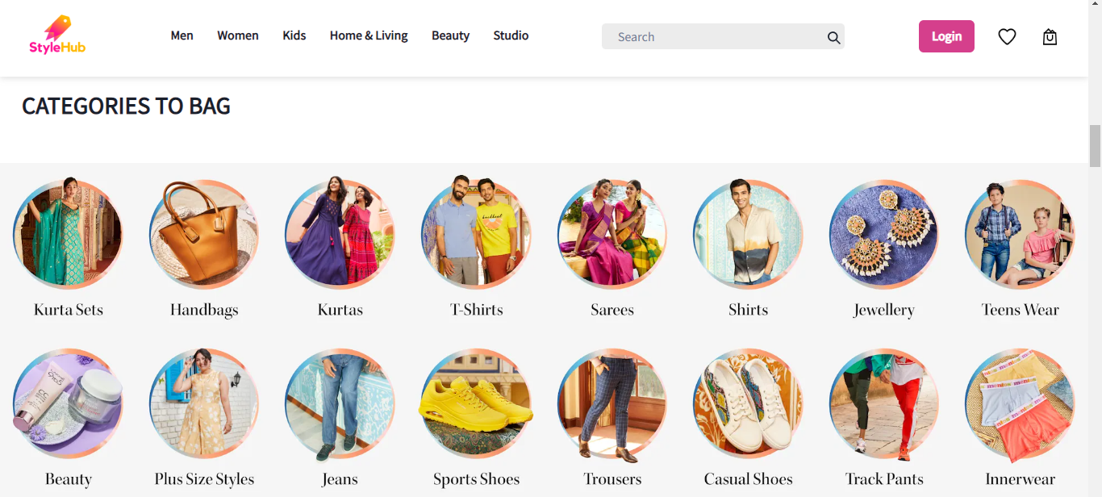

**Fig 4.1.1 RESULT**

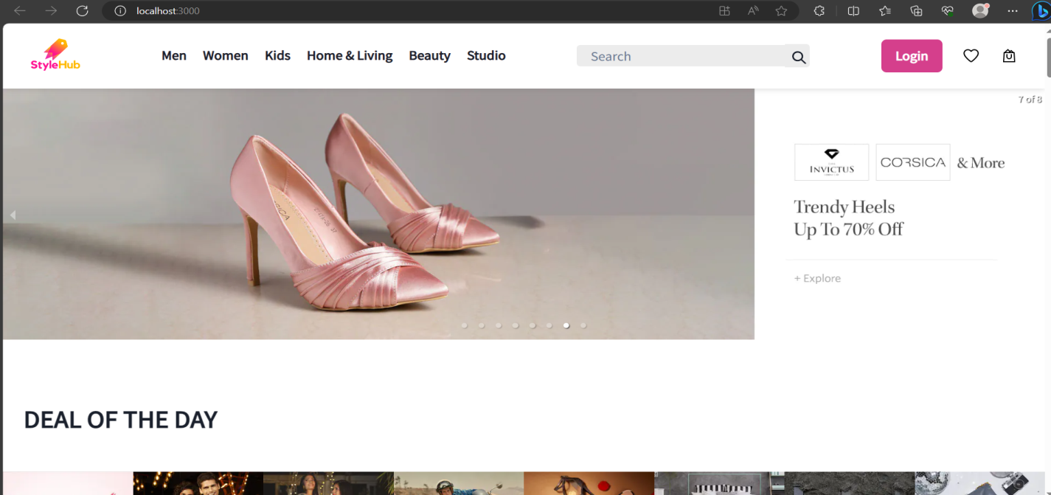

**Fig 4.1.2 RESULT PAGE(HOME SCREEN)**

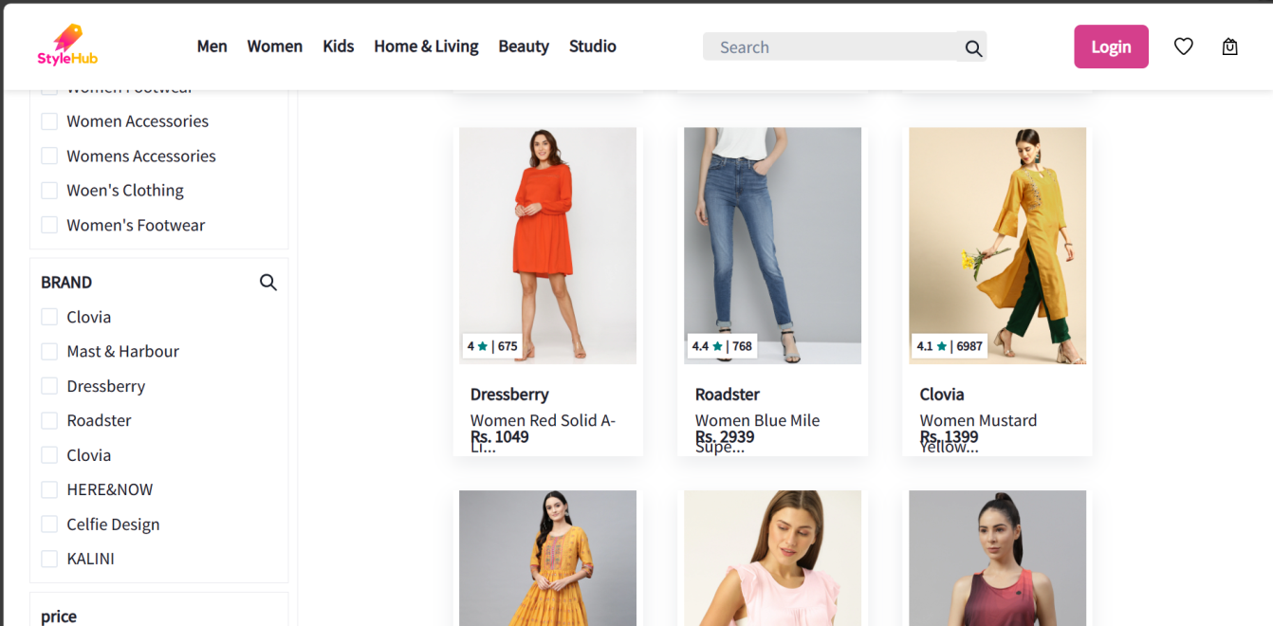

**Fig 4.1.3 CATEGORIES**

## C:\Users\HP\Desktop\Screenshots\Screenshot (1316).png

**Fig 4.1.4 WEBSITE**

## CHAPTER – 5

## CONCLUSION AND REFERENCES

## 5.1CONCLUSION:

E-commerce is now being widely used in a variety of businesses. E-commerce is a way of encoding more information than a traditional bar code. And most importantly, it contains information that can be easily decoded at high speed.

It is shown that how to create the E-commerces via the web browser that facilitates users to easily create their own E-commerces for websites, emails, business cards, print ads and so on. The proposed method was developed using entirely open-source software such as Visual Studio, and python API library.

E-commerces have made lives much easier for humanity. One can easily track their Goods and Services on their app or scan a crypto wallet E-commerce to send or receive money; just scan a block of code, and all the needed data are available.

  E-commerce still represents one of the business methods that take advantage if done the right way, even if the stock market and commodities fell, but E-Commerce still able to survive and receive high transaction.Crypto wallet E-commerce to send or receive money; just scan a block of code, and all the needed data are available.E-commerce still represents one of the business methods that take advantage if done the right way, even if the stock market and commodities fell, but E-Commerce still able to survive and receive high transaction.

**5.2 REFERENCES:**

1. Gunter Ollmann; “Security Best Practice: Host Naming & URL Conventions”, Security considerations for web-based applications, Next Generation Security Software Ltd., 2005.
2. Fielding R, Reschke J. RFC 7230 - Hypertext Transfer Protocol (HTTP/1.1): Message Syntax and Routing. June 2014. [Online]. Available: <https://tools.ietf.org/html/rfc7230#section-3.1.1>.
3. E-commerce – Wikipedia <https://en.m.wikipedia.org/wiki/E-commerce>
4. Speech on E-Commerce: Meaning, Characteristics and Other Details
5. Essay on E-Commerce: Meaning, Advantages and Disadvantages
6. Refered from <https://github.com/bharat24862486/valid-circle-9091.git>
7. Survey from Georgia University [https://www2.isye.gatech.edu/~pinar/ecom.html#usage](https://www2.isye.gatech.edu/~pinar/ecom.html)
8. Gurak, L. (2001). Shopping at the E-Mall. In Cyberliteracy: Navigating the Internet with Awareness (pp. 128-144). New Haven; London: Yale University Press. Retrieved from <http://www.jstor.org.ezlibproxy1.ntu.edu.sg/stable/j.ctt1nq4x0.11>
9. Hoyer, W.D., McInnis, D.J. Pieters, R. (2013). Consumer Behavior, 6th edition, South-Western CengageLearning. ISBN 10: 11334435211 ISBN